Visual Literacy
Use the cartoon below and answer the following questions in full sentences.
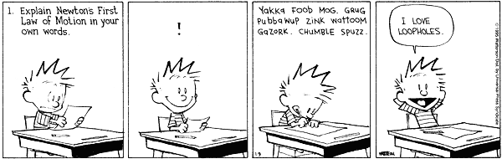
- What does “I love loopholes” mean in this cartoon?
____________________________________________________________________________________________________________________________________________________________________________________________________________________________________________________________________________________

- What is Calvin feeling when he first reads the question?
____________________________________________________________________________________________________________________________________________________________________________________________________________________________________________________________________________________

- What makes Calvin happy in the second frame?
____________________________________________________________________________________________________________________________________________________________________________________________________________________________________________________________________________________

- In the third frame, what is Calvin writing and why?
____________________________________________________________________________________________________________________________________________________________________________________________________________________________________________________________________________________

- Making an inference, what do you think Calvin’s teacher would say after reading Calvin’s answer and listening to his explanation?
____________________________________________________________________________________________________________________________________________________________________________________________________________________________________________________________________________________

