Green Exercise: No-Gym-Required Workout in the Park
Santa Monica, CA, USA | Wed Jul 22 13:00:00 GMT 2009

Try Jennifer's 20-minute circuit workout that you can do just by going to the park in your neighborhood. Repeat this cardio and strength circuit 3 times for calorie-blasting results.

Park Bench Dips
Sit on a park bench, palms on the edge of the bench, fingers facing, elbows straight. Lift your body weight up and out just so that your butt is hovering just in front of the seat with your palms firmly planted on the bench to hold you up. Your knees should be bent and your feet flat on the ground. Bend your elbows to a 90-degree angle and then straighten to dip down and up. Be sure not to rock back and forth away from and back to the bench. Instead, keep your back very close to the bench during the entire movement and limit the movement to up and down. Do 12-15 reps.
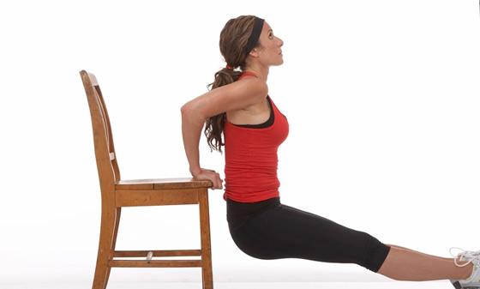

Park Bench Split Lunge

This one's great for your butt! Begin by standing about 3 feet in front of the bench (with your back to the bench) with your hands on your hips. Place your right foot on the bench behind you. Make sure your left leg is still straight in alignment with your upper body and bend down to a 90 degree angle so the your elevated knee almost touches the ground. Repeat this 12-15 times then switch to other leg.
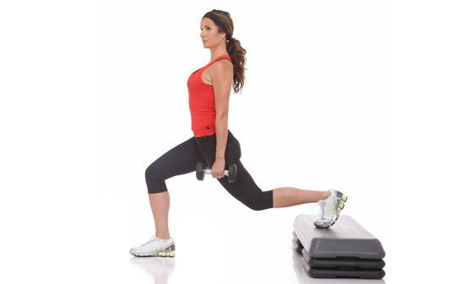

Speed Skating
Standing with your feet hip-width apart, bend your body from the waist. Put weight on your right leg, keeping your right knee slightly bent and your abs pulling in. Swing your arms to the right, then quickly push off your right foot shifting your body weight and your arms to the left. Once you have the motion, you can jump it—shifting from one foot to the other. Repeat this skater-like motion for 30 seconds and work your way up to 1 minute and so on.
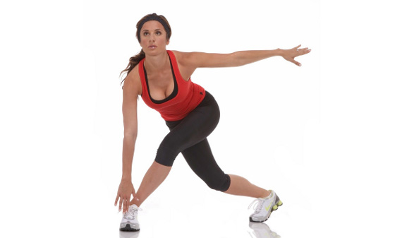

Decline Push-ups with Swing

I love this one because it works every muscle group in your entire body, forcing you to stabilize! Start by placing the tops of your feet in the swing seat and your hands flat on ground about shoulder width apart (this is the top of a push-up position, but your feet are elevated instead of being on the ground so that your entire torso and legs are parallel to the ground). Your body should be perfectly straight.
Just holding yourself in this position can be a challenge if you are just starting a workout program.
Now slowly bend your elbows and lower your chest to the ground (without arching your back and bending your waist). Then push back up to the starting position. Be sure to breathe out as you push your body up. Do 10-12 reps.
If this is way too challenging you can place your feet on the park bench instead and then work your way up to using the swing.
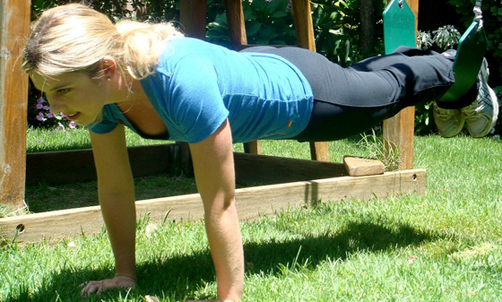

Crunches with Swing

Lay on your back on the ground with a distance the length of your legs in front of the swing set. Lift your legs and put the back of your feet in the swing seat. Place your hands behind your head with your elbows out to the sides. Lift your head and shoulders off the ground and simultaneously pull your legs in towards your chest. This movement should not coming from your neck, but you are using your abs to power the sit up. Make sure that your chin is off your chest. Breathe. Do 12-15 reps.
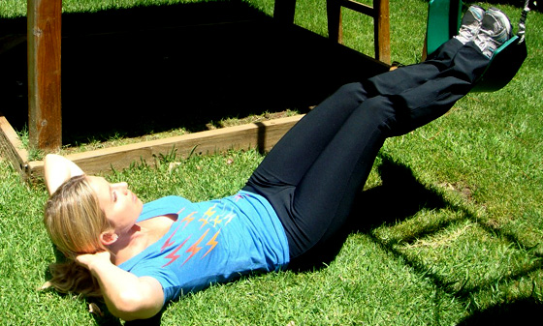

Crab Walk

Lie on your back face up. Lower your body into a supine position with your hands out to your sides about 10 inches from your shoulders. Push yourself into a "crab" or "bridge" position. Your legs should be bent with feet positioned just below your knees. Walk forward then backwards in this position for as many steps as you can without falling. Do 25 back and another 25 forward.
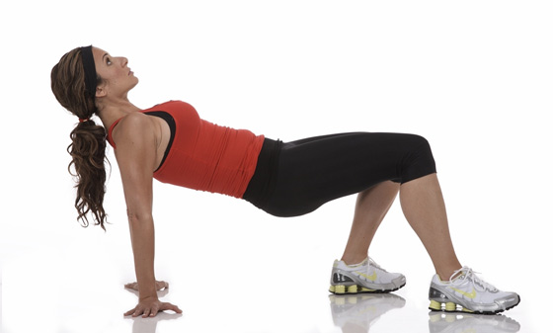

Repeat the entire circuit 2 more times and you will be on your way to a gorgeous green bikini body!

